SUMMARY OF RESULTS FOR RETAIL CLOTHING COMPANY

The present is the report for draw the conclusions needed by the business.

We had 5 important questions to ask, following is the answer to each of these.

Analysis Questions:
- What is the correlation (R2 value) between sales and income?

The correlation between Sales and Income is 0.78. The following chart presents the scatterplot for the linear regression between the variables and the corresponding card with R2 value calculated.
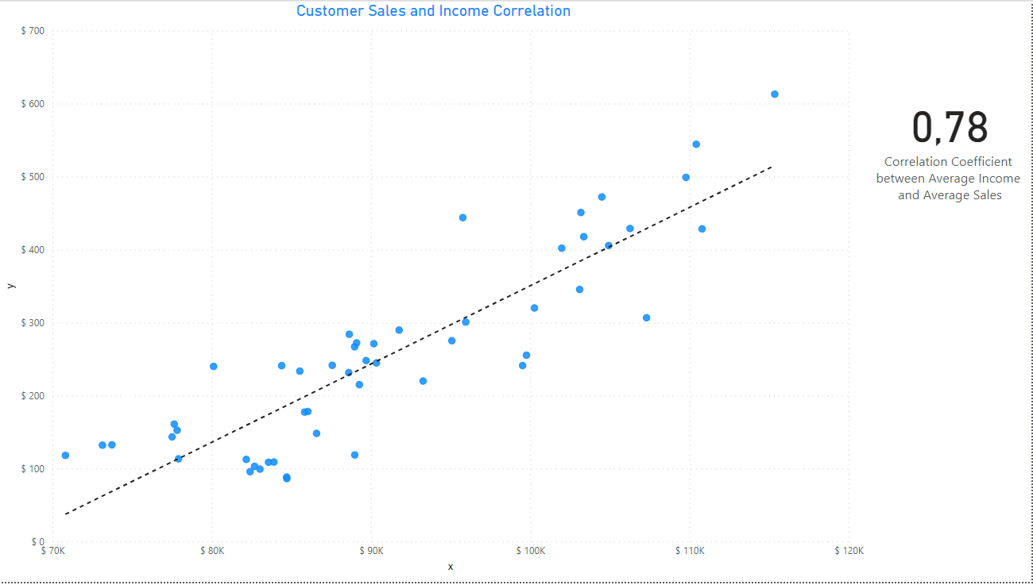

- What is the correlation (R2 value) between customer ratings and product return rate?

The correlation between Customer Ratings and product return rate is -0.83, which means that the return rate is being reduced with highest customer ratings products. The following chart presents the scatterplot for the linear regression between the variables and the corresponding card with R2 value calculated.
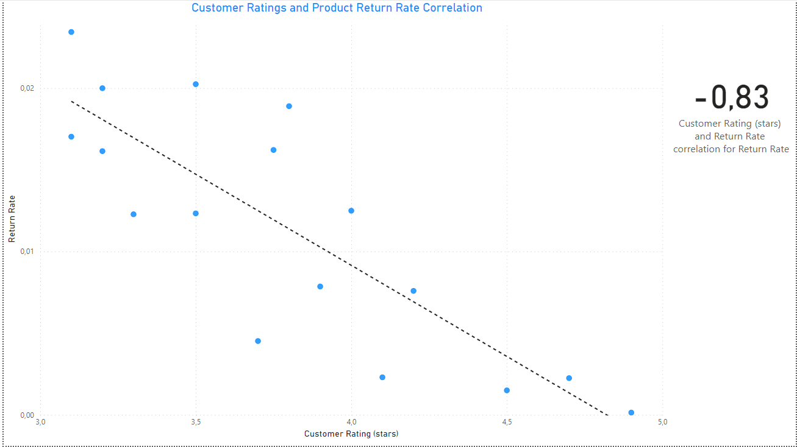

- What are the linear regression formulas to predict customer sales and customer incomes?

The linear regression formulas are the following:
For predict customer sales we use y = 0.0107x - 722.14
For predict customer incomes we use x = (-722.14 – y) / -0.0107

- Which customer do you predict has the highest income?

The customer with the highest income predicted is Jon Little from Illinois, born June 3 of 1984. He did purchases for $5250 in the last 6 months, and his predicted income is $558143,93.
We recommended the leather bag to offer him.

- Which product will be advertised the most?
The most advertised product is going to be the sweater with a $100 price. This is determined by the predicted income and sales for each customer.
It is going to be recommended to 660 customers, representing 66% of the total.
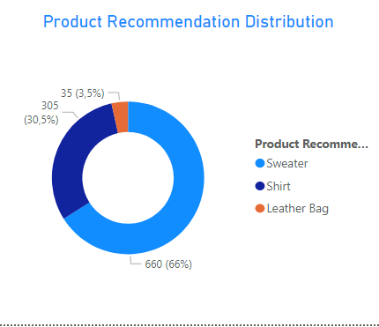

In addition we find some insights for the Products.

We have a strong potential sales for the chronograph watch, being the product with best customer rating, and also the lowest return rate.
According to its $350 price and stock of 65 units, it has potential to made $22k sales.

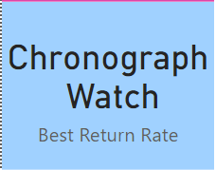

The Long Dress priced at $125 is also a great opportunity, with 4.50 rating stars, and 373 units in stock, making a potential of almost $47k sales.

